How to hide overflow text in Excel

By hiding overflow text, you can ensure that the content within a cell is neatly contained and doesn't spill over into adjacent cells. This helps maintain a clean and organized appearance, particularly when working with large datasets or when printing the spreadsheet.

Let's imagine a scenario where we are engaging in an Excel study session. To enhance our learning experience, we have incorporated hyperlinks within the Excel document. These hyperlinks are specifically placed to provide quick access to relevant topics and resources related to Excel. We want to hide overflow of text in cells because they cover unnecessary space over other cells.

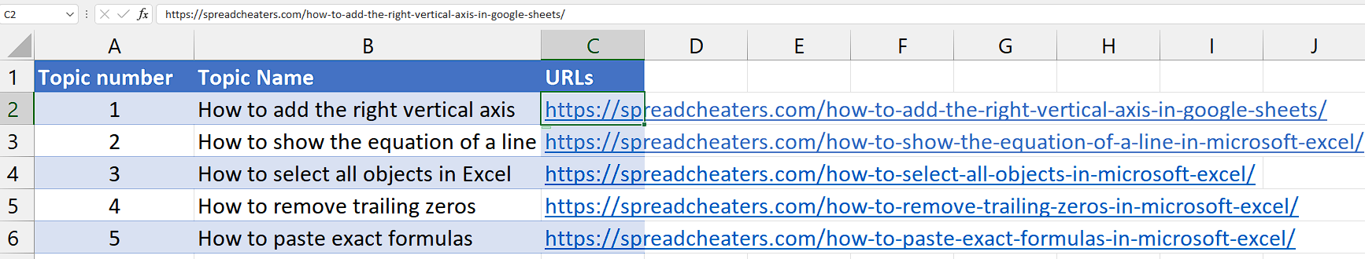

## Step 1 – Select the cells

* First of all, select the cells which contains the overflowing text.



## Step 2 – Open the “Alignment” group launcher

* Navigate to “Home” tab.
* Then, locate the “Alignment” group.
* Click on the little arrow at the bottom right corner of this group.
* It is called a launcher.
* It will open a dialogue box with several options.



## Step 3 – Hide the overflowing text

* Locate the drop-down box named “Horizontal” under the “Text Alignment” option.
* Click on the arrow adjacent to the “Horizontal” Alignment option.
* Now, click on the Fill option and click on “OK” to hide the overflow of text in the selected cells.

